**Report “Lab 2”**

**Anton Tserakhau**

# Advanced Grouping tasks – Reports

## Task 03: CREATE Test AdHoc SQL - Daily Reports (CUBE)

I have created adhoc SQL script, which will calculate Daily Reports (According report layouts on task 01):

SELECT restaurant_name

, restaurant_address

, dish_type_name

, TO_CHAR ( amount

, '9,999,999' )

AS amount

, TO_CHAR ( total_price

, '$999,999,999.00' )

AS total_price

FROM ( SELECT DECODE ( GROUPING ( rest.restaurant_name ), 1, 'All Restaurants', rest.restaurant_name )

AS restaurant_name

, DECODE ( GROUPING ( rest.restaurant_address ), 1, 'All Restaurants', rest.restaurant_address )

AS restaurant_address

, DECODE ( GROUPING ( dish.dish_type_name ), 1, 'All Types', dish.dish_type_name ) AS dish_type_name

, SUM ( oper.unit_amount ) AS amount

, SUM ( oper.total_price_dol ) AS total_price

FROM cls_operations oper

LEFT JOIN (SELECT ROWNUM restaurant_id

, t.*

FROM cls_restaurants t) rest

ON oper.restaurant_id = rest.restaurant_id

LEFT JOIN (SELECT ROWNUM dish_id

, d.*

FROM cls_dishes d) dish

ON dish.dish_id = oper.dish_id

WHERE TRUNC ( oper.event_dt

, 'DD' ) = TO_DATE ( '06-JAN-2012'

, 'DD-MON-YYYY' )

AND rest.restaurant_country_name = 'Germany'

AND rest.restaurant_city = 'Chemnitz'

GROUP BY CUBE ( ( rest.restaurant_name, rest.restaurant_address ), dish.dish_type_name )

ORDER BY rest.restaurant_name

, rest.restaurant_address

, dish.dish_type_name);

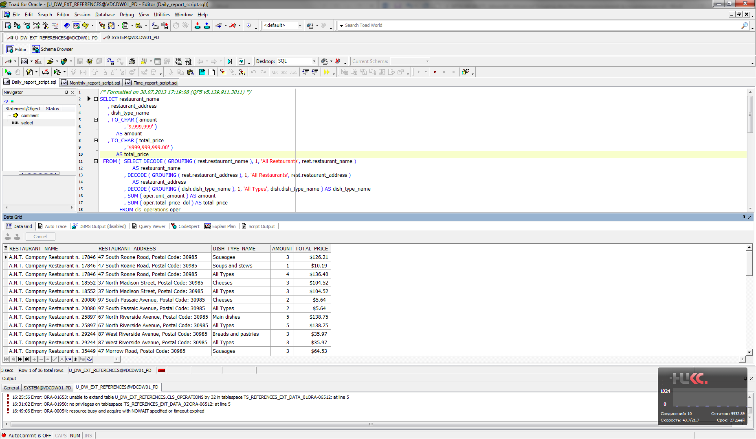

## Task 04: CREATE Test AdHoc SQL - Monthly Reports (ROLLUP)

I have created adhoc SQL script, which will calculate Monthly Reports (According report layouts on task 02).

SELECT restaurant_country_name AS country

, restaurant_city AS city

, TO_CHAR ( amount

, '9,999,999' )

AS amount

, TO_CHAR ( total_price

, '$999,999,999,999' )

AS total_price

FROM ( SELECT DECODE ( GROUPING ( rest.restaurant_country_name ), 1, 'All Countries', rest.restaurant_country_name )

AS restaurant_country_name

, DECODE ( GROUPING ( rest.restaurant_city ), 1, 'All Cities', rest.restaurant_city ) AS restaurant_city

, SUM ( oper.unit_amount ) AS amount

, SUM ( oper.total_price_dol ) AS total_price

FROM cls_operations oper

LEFT JOIN (SELECT ROWNUM restaurant_id

, t.*

FROM cls_restaurants t) rest

ON oper.restaurant_id = rest.restaurant_id

LEFT JOIN (SELECT ROWNUM dish_id

, d.*

FROM cls_dishes d) dish

ON dish.dish_id = oper.dish_id

WHERE TRUNC ( oper.event_dt

, 'MONTH' ) = TO_DATE ( '01-JAN-2012'

, 'DD-MON-YYYY' )

GROUP BY ROLLUP ( rest.restaurant_country_name, rest.restaurant_city )

ORDER BY rest.restaurant_country_name

, rest.restaurant_city);

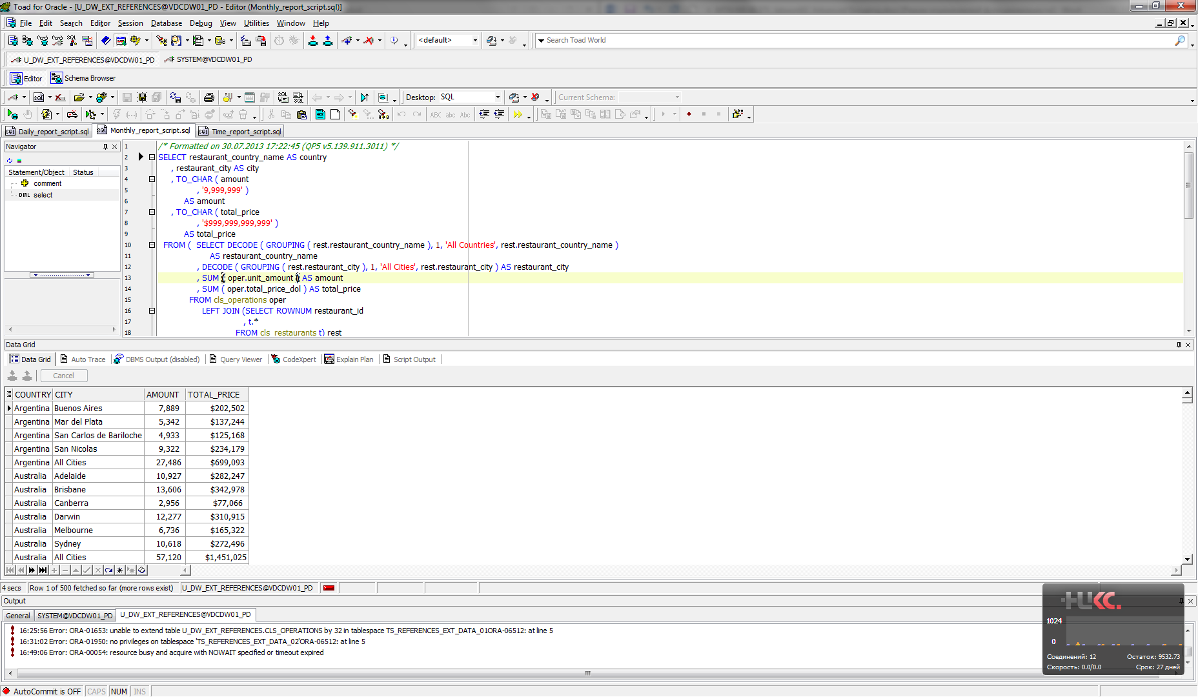

## Task 05: CREATE Test AdHoc SQL – ROLLUP by Time

I have created adhoc SQL script, which will calculate Time Based Reports.

Measurements are calculated by next levels:

• DAY

• MONTH

• QUARTER

• YEAR

SELECT year_numb

, quarter_numb

, month_mm

, month_month

, week

, day_dd

, day_day

, SUM ( unit_amount ) AS amount

, SUM ( total_price_dol ) AS total_price

FROM (SELECT oper.event_dt

, TO_CHAR ( TRUNC ( oper.event_dt

, 'DD' )

, 'DD' )

AS day_dd

, TO_CHAR ( TRUNC ( oper.event_dt

, 'DD' )

, 'Day' )

AS day_day

, TO_CHAR ( TRUNC ( oper.event_dt

, 'W' )

, 'W' )

AS week

, TO_CHAR ( TRUNC ( oper.event_dt

, 'MM' )

, 'MM' )

AS month_mm

, TO_CHAR ( TRUNC ( oper.event_dt

, 'MM' )

, 'Month' )

AS month_month

, TO_CHAR ( TRUNC ( oper.event_dt

, 'Q' )

, 'Q' )

AS quarter_numb

, TO_CHAR ( TRUNC ( oper.event_dt

, 'YYYY' )

, 'YYYY' )

AS year_numb

, oper.unit_amount

, oper.total_price_dol

FROM cls_operations oper)

GROUP BY ROLLUP ( year_numb, quarter_numb, ( month_mm, month_month ), week, ( day_dd, day_day ) )

ORDER BY year_numb

, quarter_numb

, month_mm

, week

, day_dd;

